Tampere University Unit of Computing Sciences

TIEA4 Project Work (City centre campus)

TIETS19 Software Project Management Practice (City centre campus)

Ryhmä 8 - Pallas

Snowledge Digitalized

Project plan

Note: All texts in this document that are colored blue are instructive and should be replaced with actual text by you. They just tell what should be included in each section.

|  |
| --- |
| 88018, Sakari Eskelinen  432222, Kaisa Kauhanen  424492, Arttu Lakkala  428786, Aarre Leinonen  93003, Markku Nirkkonen |
| K382694, Johanna Pekki |

Version history

|  |  |  |  |
| --- | --- | --- | --- |
| Version | Date | Author | Description |
| 0.1 | 21.9.2020 | All members | First draft |
|  |  |  |  |
|  |  |  |  |
|  |  |  |  |
|  |  |  |  |
|  |  |  |  |
|  |  |  |  |
|  |  |  |  |
|  |  |  |  |
|  |  |  |  |

Contents

1 Introduction 4

1.1 Purpose and scope of project 4

1.2 Product and environment 4

1.3 Customer's current system and other similar systems 4

1.4 Project constraints 4

1.5 Definitions, abbreviations and acronyms 4

2 Project organisation 5

2.1 Group members 5

2.2 Customer 5

2.3 Related organisations 5

3 Project goals and ending/termination 5

3.1 High level goals of the project group 5

3.2 High level goals of the customer 5

3.3 High level goals and deliverable(s) of the project 5

3.4 Quitting (termination) criteria of the project 6

3.5 Ending criteria of the project 6

4 Project and Process management 6

4.1 Methods and tools 6

4.2 Planned meetings 6

4.3 Learning and study plan 7

5 Project iterations and timing 7

5.1 Iterations (sprints) 7

5.1.1 Iteration 0 8

5.1.2 Iteration 1 (first implementation sprint) 8

5.1.3 Iteration x 8

5.1.4 Iteration z (quality assurance) 8

6 Requirements 9

6.1 Functional requirements (main goals) 9

6.2 Non-functional requirements goals 9

6.2.1 Usability goals 9

6.2.2 Performance goals 9

6.2.3 Reliability goals 9

6.2.4 Security goals 9

6.3 User interface requirements (main goals) 9

7 Risk management 9

7.1 Risk list 10

7.2 Risk monitoring 10

8 References 11

9 Open issues 11

10 Ideas for further development 11

APPENDIX A […Z] 11

# Introduction

## Purpose and scope of project

Purpose of this document is to provide an all-around picture of the project, its constraints, risks and progression. This document is not necessarily how the project must be done, rather than guidelines for the project and plans at the moment. If necessary, this document can be updated to better reflect current state of the project. Scope of the project is to create a functional software following clients requests and general guidelines.

## Product and environment

Project goal is to create a software that can receive information about the snow situation of certain areas, simplifying and delivering that information to users. Functionality will be implemented as a website, which can be updated with new data by admins and accessed from any platform. The basic idea is to take the data that admins provide, calculate snow attributes and then simplify that information to users using a map and highlighting certain areas of the map with different colours or symbols so that the user can see what kind of snow that area contains. Intended users are everyone needing information about the snow situation around Pallastunturi area

## Customer's current system and other similar systems

Customer does not have any system like this yet. One mentioned slightly similar system is an app called Fatmap. It provides 3D world map view and users can record their walking or skiing etc. routes which then will be accessible for everyone using the app. It can also display some characteristics of the area, though not so specifically that our customer wanted.

## Project constraints

The main technology constraint is the acquisition of the webserver and our access to it. We should be able to get a server space from Lapland hotels however this is yet to be fully determined. In addition to this we might need to license mapping software if we end up taking that route in our implementation.

## Definitions, abbreviations and acronyms

Admin: Person who updates website with admin privileges

User: Persons who use website to get information about snow situation

End-users: Admins and users

Developer: Team members developing the software

API: Application programming interface

MMT: Metrics monitoring tool provided by university for project management

UI: User interface

# Project organisation

## Group members

Sakari Eskelinen, [sakari.t.eskelinen@tuni.fi](mailto:sakari.t.eskelinen@tuni.fi) 0456755873. First timer as a project manager. Previously acted as a developer with few programming languages such as Java, Javascript and C# (Unity). Studying part-time, alongside a “80% full-time" job in IT field; daytimes are mostly for work, however, working hours are flexible.

Kaisa Kauhanen, [kaisa.kauhanen@tuni.fi](mailto:kaisa.kauhanen@tuni.fi), 0440982507. Experiences in UI design, programming and quality assurance. Flexible working hours.

Arttu Lakkala, [arttu.lakkala@tuni.fi](mailto:arttu.lakkala@tuni.fi) 0443065061. Main experience in programming with multiple languages. Also, some limited experience in data visualisation.

Aarre Leinonen, [aarre.leinonen@tuni.fi](mailto:aarre.leinonen@tuni.fi), 0505624033. Main experiences in programming, mainly Java, little experience in Python and web development. Flexible working hours.

Markku Nirkkonen, [markku.nirkkonen@tuni.fi](mailto:markku.nirkkonen@tuni.fi), 0402171939. Main experiences in programming with mainly Java. Some experience of web development as well. Also very interested in UI/UX design. Working hours have to be fitted to other studies, but mainly flexible.

Johanna Pekki, [johanna.m.pekki@tuni.fi](mailto:johanna.m.pekki@tuni.fi), 0442544525. Main experiences in information processing systems of organisations and planning.

## Customer

Juuso Holstein, [juuso.holstein@laplandhotels.com](mailto:juuso.holstein@laplandhotels.com), representative of Pallaksen Pöllöt

Arto Hämäläinen, [arto.hamalainen@harte.com](mailto:arto.hamalainen@harte.com), representative of Pallaksen Pöllöt

## Related organisations

No third parties. University IT department?...

End-users will be members of Pallaksen Pöllöt, and everyone in need of information about snow attributes around Pallastunturi area.

# Project goals and ending/termination

## High level goals of the project group

The most important, high level goal of our group is that we can make a good product that the customer can be satisfied with. It is also important to stay in schedule and get the work done on time. In addition, we strive to maintain a good team spirit and keep a positive and active attitude.

## High level goals of the customer

High level goal of the customer is to receive a product that allows them to visualize snow data in the Pallas area. Primary goal is a working product, that shows the latest information about the snow situation.

## High level goals and deliverable(s) of the project

The snow data is visualized well and it’s in electronical format. At least the hotel visitors can check the snow situation from some monitors in the hotel lobby. This is the minimum requirement, but our goal is to make a broader implementation that customers can use as a web application on any device. The information should be visualized so well, that it is effortless to read and understand.

## Quitting (termination) criteria of the project

If the customer withdraws, then the project should be terminated. Also, if problems arise that cannot be solved, then the project should be quitted, but hopefully we manage to make this project ready without any major problems.

## Ending criteria of the project

The project should be ready at the end of this year. Later we probably going to agree on a certain date with the customer. The project of course ends when the product works as it should work.

## Methods and tools

Group members have decided to use Teams, Slack and Sharepoint for communications and document sharing. Project management tool is MMT. Trello is a platform for Kanban-style task listing. Version control in GIT. Email, phone and WhatsApp are also enabled. Primary Development tools is Visual Studio Code. It was thought to be enough sufficient. Webpage as a stack of HTML-CSS-JavaScript as front-end and Node.js based backend application. Google Maps planned to be used as the map base.

Interface design - decision has not yet been made - Invisionapp

More about methodology?

## Planned meetings

Group meets at least every Wednesdays and when needed. Meetings are held remotely for the present. Meetings with the customer are kept flexibly when needed.

## Learning and study plan

There will be a lot to learn about tools and technologies. Group members don’t have much experience about this kind of web development. Technical implementation can be done together by screen sharing.

# Project iterations and timing

## Iterations (sprints)

The idea is, that you list only main points here. Details are at Backlogs (group’s Kanban tool).

First Sprint 0 (zero) is for finding out requirements at least to the level when implementation can start. Setting up development environment is also going on. Project Plan is usually ready at this stage.

Implementation Sprints; number and length.

The last Sprint is for quality assurance, i.e. bug fixing and extensive system testing (also with end-users).

**Table 5.1. Project schedule.**

|  |  |
| --- | --- |
| Sprint no | Schedule (start/end date) High level content. |
| 0 | Hello World, project plan |
| 1 | Basic functionality, UI mock-up, process plan |
| 2 | Core functionality, Usable UI |
| 3 | Additional functionality and all features, Improved UI based on feedback |
| 4 | Final bug fixes, final usability updates |
|  |  |
|  |  |

### Iteration 0

* + Created Git repository
  + Created project plan
  + Created Hello World program

### Iteration 1

* + Add basic map of area to website
  + Create basic mock-up segments for the map
  + Create basic data models
  + Make an UI mock-up for user
  + Make an UI mock-up for data upload

### Iteration 2

* + Create appropriate segments for map
  + Add mock-data to models
  + Create basic UI for user
  + Create basic UI for data upload

### Iteration 3

* + Implement weather data from measuring stations
  + Improve UI based on feedback (2 Iteration)

### Iteration 4

* + Finalize development
  + Fix any major bugs
  + Testing
  + Minor UI improvements based on feedback

# Requirements

## Functional requirements (main goals)

1.The server should be operational and connectable for users.

2.The administrator should be able to upload up to date information of the snow situation to the server easily and without technical knowledge.

3.The up to date information should be displayed to the user by area upon request. The data has both basic cartographical visualisation and more detailed info upon request.

4.Automated data from the measuring stations should be integrated to the cartographical visualisation.

5.If possible future situation should be adjusted based on measuring station data.

## Non-functional requirements goals

### Usability goals

The user should be able to get the needed data of snow conditions in an easily understandable form from the website. Advanced user should also be able to get more detailed data.

The administrator should be able to upload data to the website regularly so that the data stays up to date.

### Performance goals

The website should respond in a few second on a relatively good connection. In case of 3d visualisation the content may take longer to come up.

### Reliability goals

The program should reliably display the current up to date info and to be stable enough to be usable in planning.

### Security goals

The administration login should be stored in a safe way to prevent access from outside parties.

## User interface requirements (main goals)

The accessing of the website should be relatively intuitive and easy to learn. The user should be able to understand the basic functionality of the site without any training.

Uploading of the data should also be easy and not require any technical knowledge. However, some limited training can be necessary for first time users.

# Risk management

Arguably the main method of risk management in the team is to attempt to keep other members informed about how things are going and discussing about progress and situation. At the same time it is important to keep up good team spirit, which is maintained by communication, everyone’s good treatment of fellow teammates and by attempting to distribute works equally for the parts possible. A member who is content or even happy with the team and its members is much more likely to do good work on his/her own part and to help other members when needed.

Other ways to mitigate possible damage caused by realized risks are to have plans and preparations beforehand, try to learn tools before using them too intensively and attempting to keep realistic schedules. Of course for some parts it can be difficult to estimate beforehand for instance how much effort and time something will take, partially due lack of experience within the group members. Nevertheless, also for that reason the intention is to not try to implement too ambitious application with very intense schedule, as that would be very prone to fail.

## Risk list

List of identified risks below. Obviously, there are more risks that are theoretically potential, and odds are that not everything is taken into account. In addition risks of extremely unlikely odds or insignificant severity are not necessarily listed up, even if they would actually be acknowledged.

**Table 6.1. Project risks.**

| Risk ID | Explanation , severity/impact , probability , size/importance |
| --- | --- |
| Sickness | A member of the team gets sick (or injured), and can’t work with the project. Severity 3, probability 3 -> importance 9. |
| Order Cancellation | The orderer cancels the project for whatever reason. Severity 5, probability 1 -> importance 5. |
| Lack of Skills | Members of the team lack sufficient skills to complete the project (without further training). Severity 4, probability 4 -> importance 16. |
| Delays | The project schedule gets delayed due to other risks getting realized or for some unforeseen reasons. Severity 3, probability 3 -> importance 9. |
| Technical issues, minor | Someone of the team gets a technical breakdown; for instance computer at home breaks down or some other crucial work hindering system for a member becomes unusable. Severity 3, probability 2 -> importance 6. |
| Technical issues, major | Larger scale technical issue occurs, affecting the whole team, such as local network getting down or a central tool becomes unusable for the project. Severity 4, probability 1 -> importance 4. |
|  |  |

## Risk monitoring

Monitoring of risks is largely based upon team members reporting if everything is going fine for their part. Ongoing risk monitoring and management will be in addition in MMT tool, so in case new risks are identified during the project, they will be added there.

# References

--

# Open issues

Server requirements are still to be determined more specifically. Customer has several possible servers for the application to run on and final solution depends on requirements of the application.

Pricing of the use of Google Maps API is still a little bit open question. It may affect to the final choice of map API, but not likely since a blink of green light already was given by the customer.

Final choice of application for UI design is yet to be made. That, however, is a decision that can and will be made without customer or third party.

# Ideas for further development

Possibility to expand the use of application easily for another customer (other area) will be left for further development at this point.

Further development of UI could aim for more straightforward graphical way of managing the system data (managing certain areas and snow information of them). That is most likely out of range at this point and UI has to be simple.

Versatile use of publicly available weather data is partly a matter of further development. Some use of weather data most likely will be implemented already in the initial project, but it might be relatively simple use of that data at this point.

# APPENDIX A […Z]

**Email from customer at 9.9.2020, to give base requirements in Finnish:**

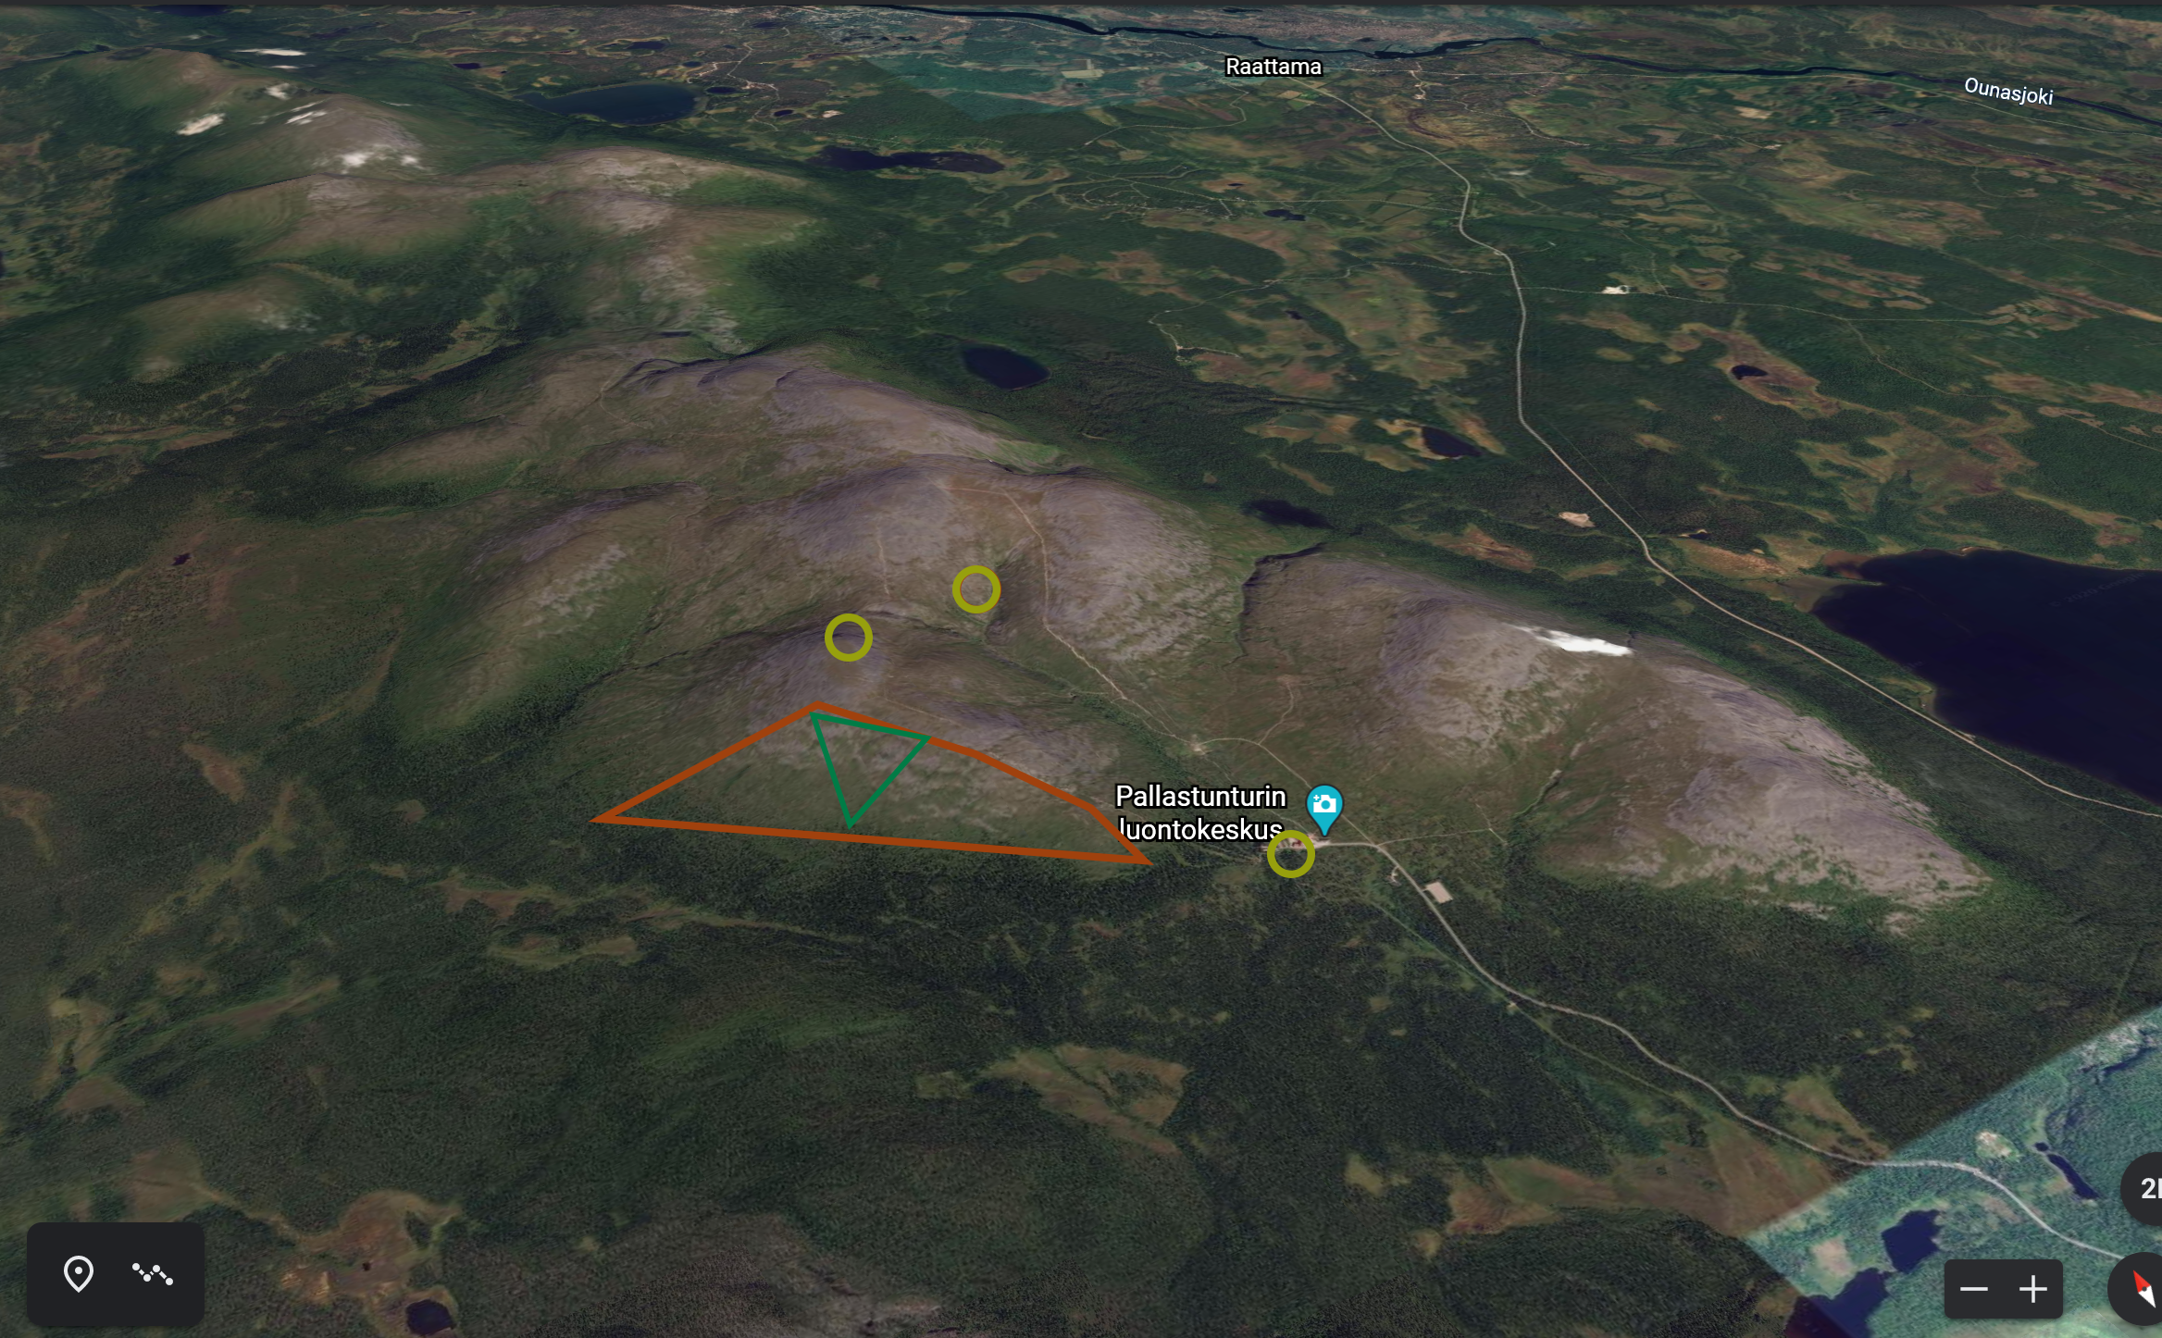

Moikka,

Tässä olisi pohjatyötä mitä ajattelimme kokonaisuuden aloittajaisiksi. Pohjana siis karttamaailma, joka tuo tuohon ymmärryksen maastosta. Todennäköisimmin hieman FATMAP pohjaa soveltaen, jollain väri/iconimaailmalla joutuisimme kertomaan lumitietoutta seuraaviin asioihin pohjautuen:

ALUESEGMENTIT

Alueet olisivat jaettu pääsegmentteihin (eli tunturialueisiin, joilla kuljetaan pääsääntöisesti hiihtäen ja ovat suurempia kokonaisalueita kuten tuntureita tai tuntureiden seinämiä)

Pääsegmenttien sisällä oleviin alasegmentteihin, jotka ovat huomattavasti specifimpejä alueita (esim. 2 km x 1 km kokoluokkaa) ja nämä ovat tarkoitettu vapaalaskijoille.

Näiden lisäksi meillä on alueena metsä, joka on kaikkialla puurajan alapuolella ja aina pääsääntöisesti samanlaista lunta.

SEGMENTTIEN SELITYKSET / LUMIMÄÄRITTEET

Pehmeä lumi

Tuulen pieksemä aaltoileva lumi

Korppu

Sohjo

Jää

Näiden lisäksi vyöryherkälle alueelle (1-2 kpl alasegmenttiä, tulisi saada näkyviin myös ns. vyöryvaroitus tai huomio vaarasta)

Jokaisesta alueesta tulisi saada lyhyt sanallinen esitys (jos niitä meidän kirjaamina on) esim. klikkaamalla

DATA

Data tulisi pääsääntöisesti omista kokemuksistamme joka päiväisessä liikkumisessa tunturialueilla. Tiedon pohjalta soveltaisimme ja laajentaisimme ymmärrystämme koskemaa näitä pääsegmenttejä

Alueen mittauspisteitä saatavaa tietoutta, jota voitaisiin soveltaa mahdollisesti seuraavin tavoin (tulee pääsääntöisesti Ilmatieteenlaitokselta esim. fmi.fi -> pallastunturi)

Jos luodaan joku päänäyttö, sen hetkiset havainnot saisivat näkyä siinä reaaliaikaisesti

* + Lämpötilan vaihtelu tietyillä mittaushistoria-ajoilla mittauspisteissä (esim. 1 kk tai talvi)
  + Tuulidata (ja sen yhdistäminen lumen liikkumiseen, eli esim. yli 7 m/s huipulla tarkoittaa lumen liikkumista)
  + Lumensyvyydet omista sähköisista mittapaikoista

Eli jos olisi mahdollista tehdä yhteen kohtaan säädata-palikka joka piirtäisi automaattisesti ”talvinäkymän”, joka osoittaisi milloin lämpötilat ovat olleet lämpimiä tai kylmiä, milloin lunta on satanut (millaista se siis on ollut) ja milloin tuuli on lunta liikuttanut.

Liitteenä oleva kuva on aivan superpelkistetty, eikä tarkoitus ole luonnollisesti noin kuvata tilannetta! Mutta hieman näkee oranssilla pääsegmentin kokoa, vihreällä alasegmentin ja noi pyörylät ovat sijainteja mistä dataa tulee (tai toiveen mukaan tulisi).

Laittakaa kyselyä ja pohdintaa heti jos jokin mietityttää!

Lappimaisin terveisin,

|  |
| --- |
| **Juuso Holstein** |
| **LUOVA • CREATIVE MANAGER** |
| +358 40 5425544 |
| [juuso.holstein@laplandhotels.com](mailto:juuso.holstein@laplandhotels.com) | @juuppe |
| Yrjö Kokon tie 4, 99300 MUONIO, FINLAND |
| **LaplandHotels.com** |